**Week 6:  Capstone Network Security Project**

**Objective:**  Simulate a secure network environment with monitoring and defense.

**Task#02: Simulate a MITM (Man-in-the-Middle) attack on your local network using Ettercap or Bettercap.**

**Solution:**

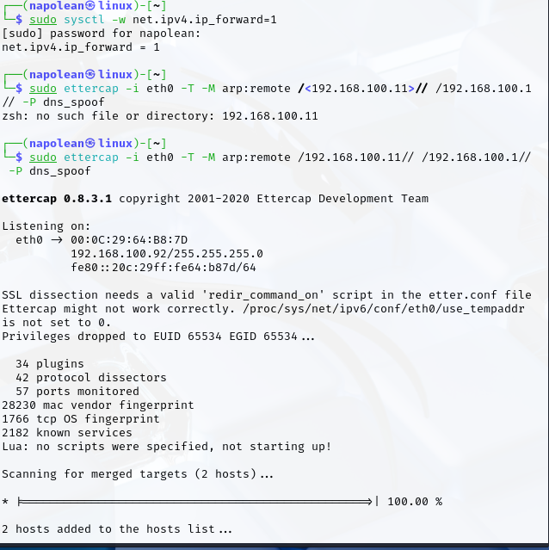

Using Ettercap, I fetch login usernames and passwords by positioning myself as a "middle-man" on a local network. I achieve this by tricking target computers into sending their internet traffic through my machine. If a victim then logs into a website or service that **does not use encryption (like an old HTTP website or FTP)**, I can directly capture and reveal those login details (username and password) as they travel across the network. I essentially "grab" the credentials because they are sent in plain, readable text.